Name: Bradley Willcott

ID: M198449

Date: 6 November 2021

Assessment Task (AT 3 Project)

Jupiter Mining Corporation

Contents

Figures 2

Debugging 4

Testing 6

References 37

Tables

Table 1: Testing results 6

# Figures

Figure 1 – Showing value of rtn – no account for: “fred1234” 4

Figure 2 - Newly created User Account details 5

Figure 3 - Startup RMI and Socket Servers 7

Figure 4 – Startup GUI Client 8

Figure 5 – Create a New Account - A 9

Figure 6 - Create a New Account - B 9

Figure 7 - Create a New Account - C 10

Figure 8 - Create a New Account - D 10

Figure 9 - Create a New Account - E 11

Figure 10 - Show User/Logout now enabled - A 11

Figure 11 – Open Chat session 12

Figure 12 – Have a Chat - A 12

Figure 13 – Have a Chat - B 13

Figure 14 – Have a Chat - C 13

Figure 15 – Have a Chat - D 14

Figure 16 – Have a Chat - E 14

Figure 17 - Close session - A 15

Figure 18 - Close session - B 15

Figure 19 - Logout - A 16

Figure 20 - Logout - B 16

Figure 21 - Show Help/About - A 17

Figure 22 - Show Help/About – B 17

Figure 23 - Help/Manual - A 18

Figure 24 - Help/Manual - B 19

Figure 25 - Login with wrong password - A 20

Figure 26 - Login with wrong password - B 20

Figure 27 - Show validation of new Username & Password - a 21

Figure 28 - Show validation of new Username & Password - B 21

Figure 29 - Show validation of new Username & Password - C 22

Figure 30 - Show validation of new Username & Password - D 22

Figure 31 - Show validation of new Username & Password - E 23

Figure 32 - Show validation of new Username & Password - F 23

Figure 33 - Show validation of new Username & Password - G 24

Figure 34 - Show validation of new Username & Password - H 24

Figure 35 - Show validation of new Username & Password - I 25

Figure 36 - Show validation of new Username & Password - J 25

Figure 37 - Logout 26

Figure 38 - Show servers running with last sessions logs 27

Figure 39 - Show both servers shutdown 28

Figure 40 - Trying to Login – Connection refused 29

Figure 41 - RMI Server (Login Server) restarted 30

Figure 42 - Login now successful 31

Figure 43 - Try to open Chat session - Connection refused 31

Figure 44 - Socket Server (Chat Server) restarted 32

Figure 45 - Chat session connected 33

Figure 46 - Logout with Chat session open - A 33

Figure 47 - Logout with Chat session open - B 34

Figure 48 - Final look at server consoles with log entries 35

Figure 49 - Close application 36

# Debugging

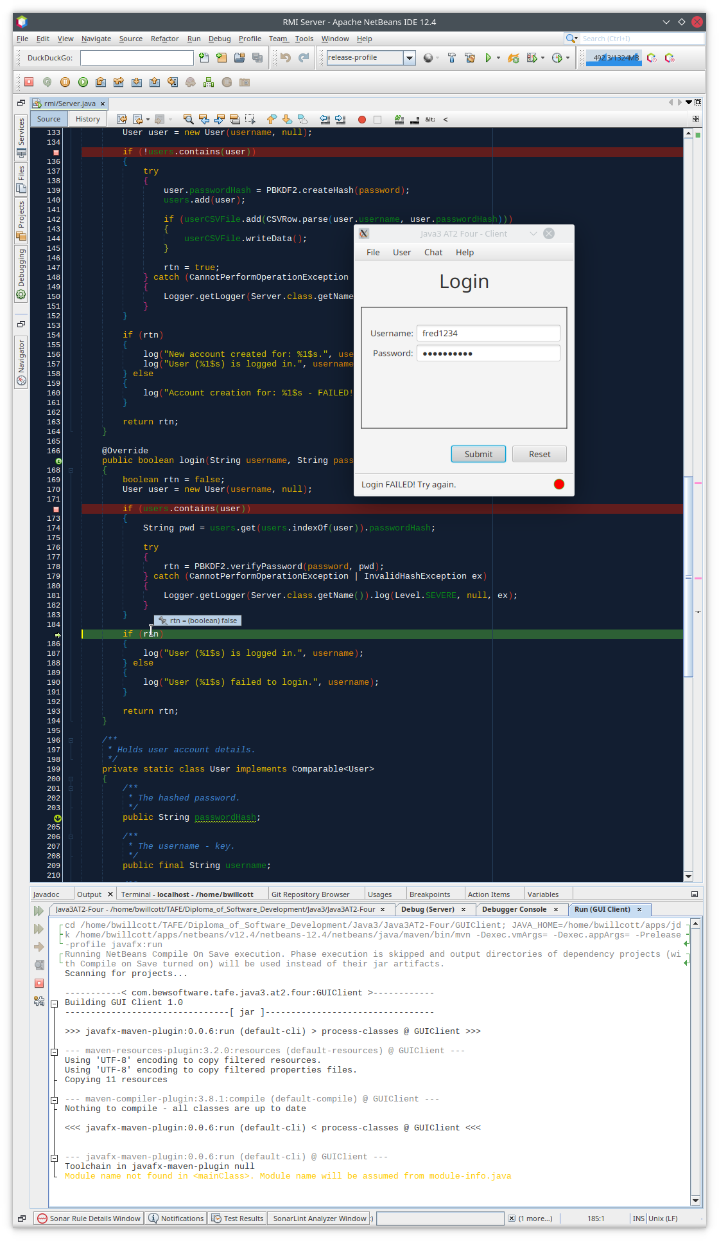

Figure – Showing value of rtn – no account for: “fred1234”

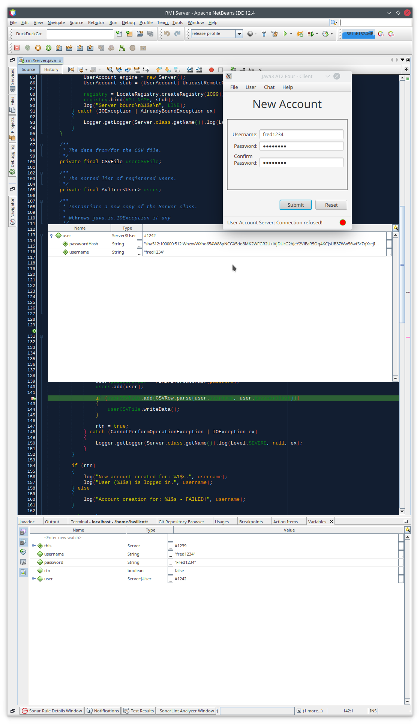

Figure - Newly created User Account details

# Testing

Table 1: Testing results

|  |  |  |  |  |
| --- | --- | --- | --- | --- |
| Case | Description | Expected | Actual | Evidence |
| #1 | Start-up RMI and Socket Servers | Display program output in separate consoles | As expected | Figure 3 |
| #2 | Start-up GUI Client | GUI Application started | As Expected | Figure 4 |
| #3 | Create a New Account | Show successful result – Message and light goes Green | As expected | Figure 5  Figure 6  Figure 7  Figure 8  Figure 9 |
| #4 | Show Logout menu item now enabled | Menu displayed | As expected | Figure 10 |
| #5 | Open Chat session | Menu displayed | As expected | Figure 11 |
| #6 | Have a Chat | Show Chat view with typed in text and responses from the Chat Server | As expected | Figure 12  Figure 13  Figure 14  Figure 15  Figure 16 |
| #7 | Close Chat session | Chat view gone | As Expected | Figure 17  Figure 18 |
| #8 | Logout | Light goes Red | As Expected | Figure 19  Figure 20 |
| #9 | Display About Dialog | Dialog displayed | As Expected | Figure 21  Figure 22 |
| #10 | Display the Help Window | Window displayed | As expected | Figure 23  Figure 24 |
| #11 | Test Login with wrong password | Error message | As Expected | Figure 25  Figure 26 |
| #12 | Show validation of new Username & Password | Show various screens as both the Username and Password are both progressed from invalid to valid | As Expected | Figure 27  Figure 28  Figure 29  Figure 30  Figure 31  Figure 32  Figure 33  Figure 34  Figure 35  Figure 36 |
| #13 | Test GUI Application with both servers down | Error message | As Expected | Figure 37  Figure 38  Figure 39  Figure 40 |
| #14 | Restart RMI Server and retry Login | Show Login success message | As Expected | Figure 41  Figure 42 |
| #15 | Try to open Chat session | Error message | As Expected | Figure 43 |
| #16 | Restart Socket Server and reopen Chat session | Chat session connected | As Expected | Figure 44  Figure 45 |
| #17 | Logout with Chat session open | [Send] button disabled and light gone Red | As Expected | Figure 46  Figure 47 |
| #18 | Final look at server consoles with log entries | Show console | As Expected | Figure 46 |
| #18 | Close the application | Done | As Expected | Figure 47 |

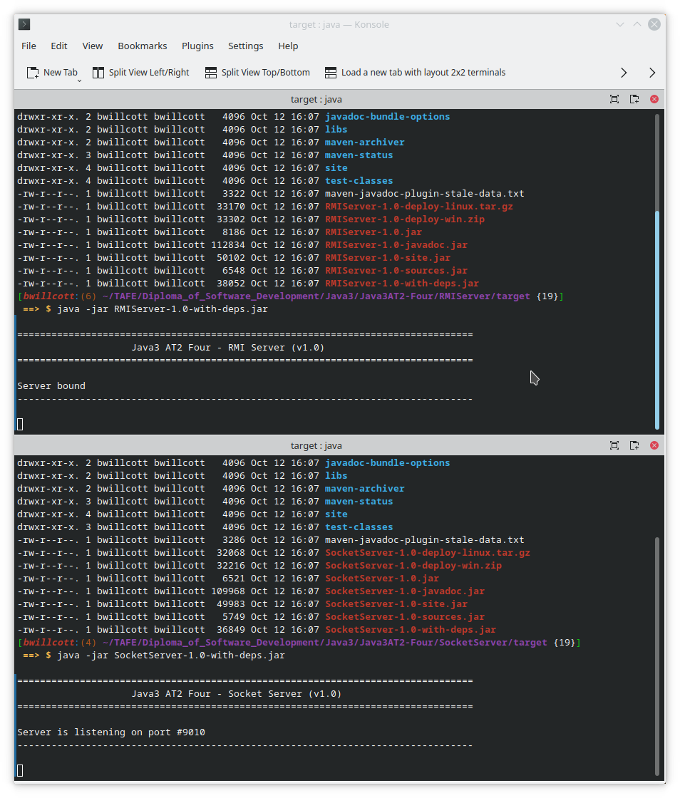

Figure - Startup RMI and Socket Servers

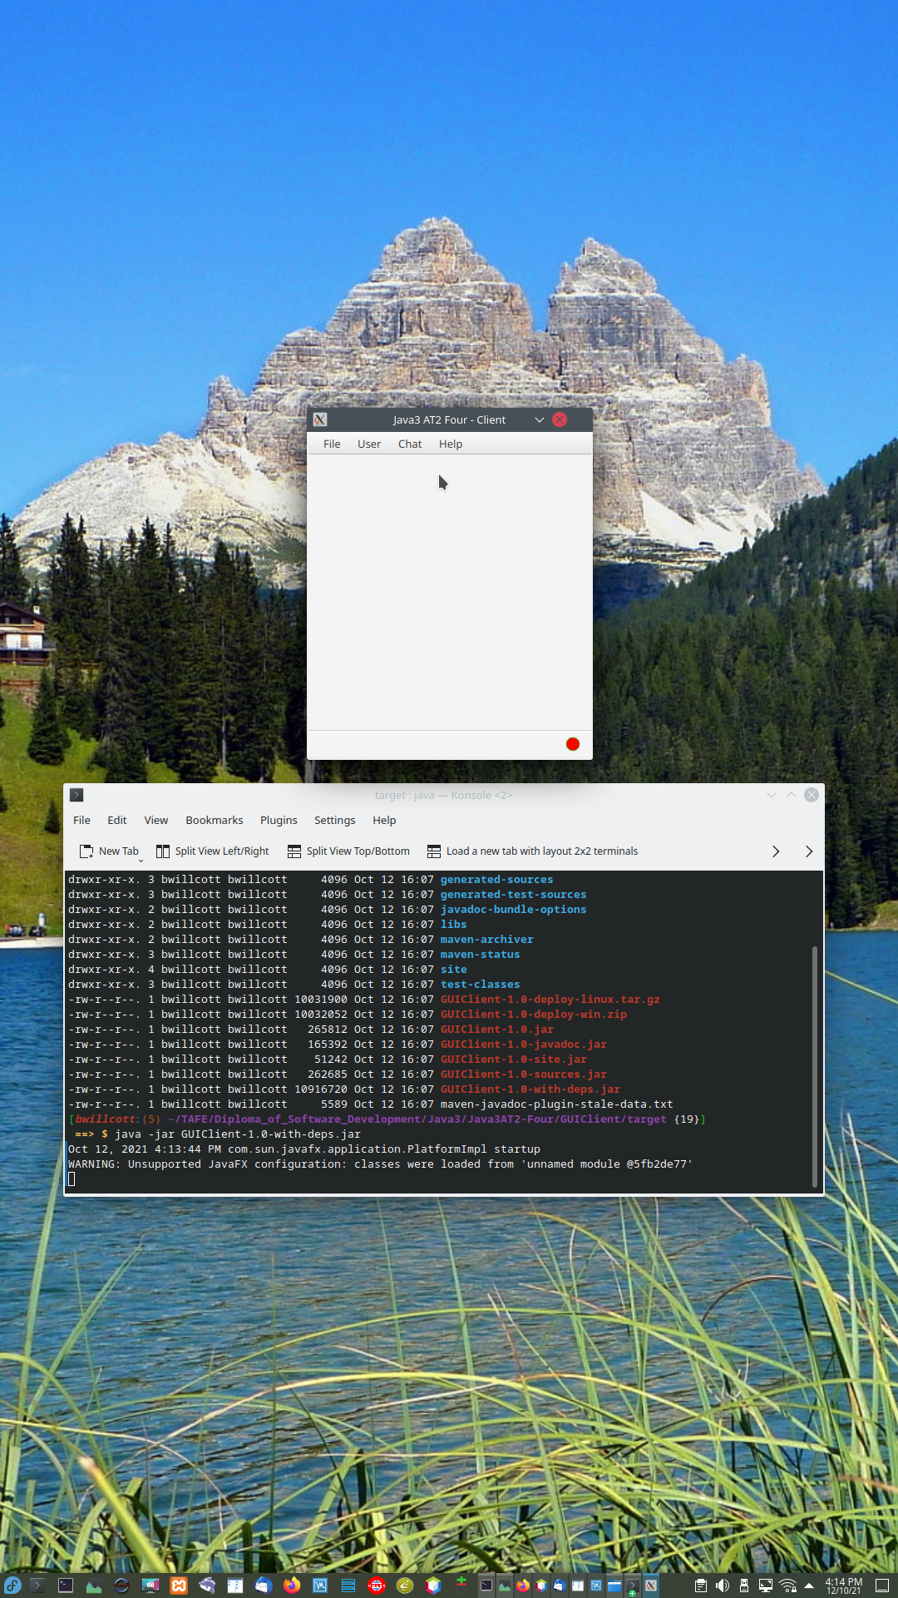

Figure – Startup GUI Client

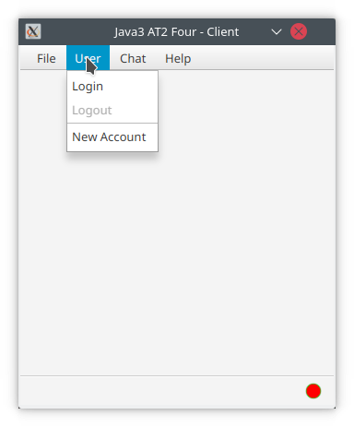

Figure 5 – Create a New Account - A

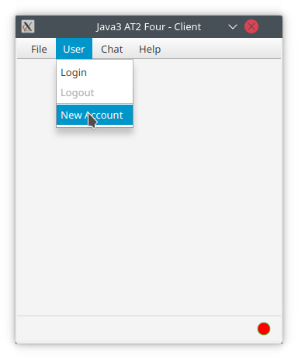

Figure 6 - Create a New Account - B

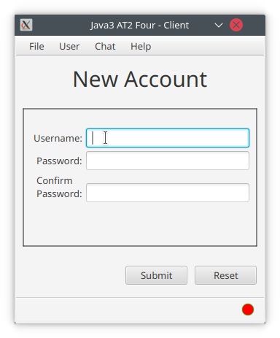

Figure 7 - Create a New Account - C

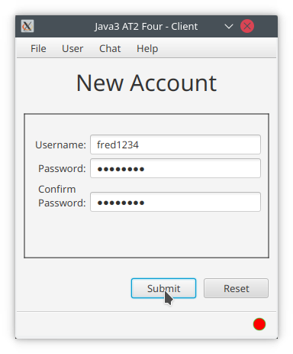

Figure 8 - Create a New Account - D

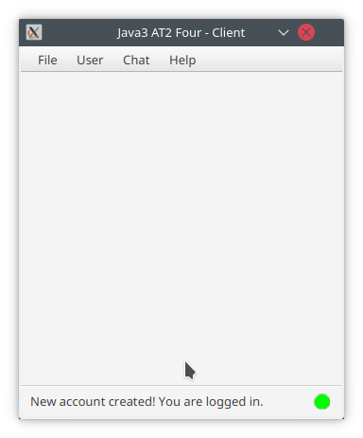

Figure 9 - Create a New Account - E

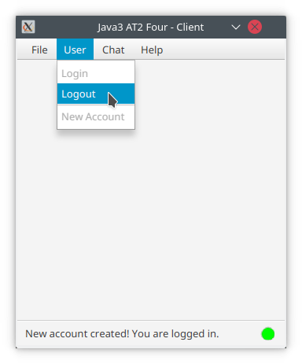

Figure 10 - Show User/Logout now enabled - A

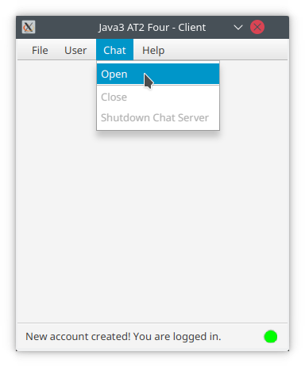

Figure 11 – Open Chat session

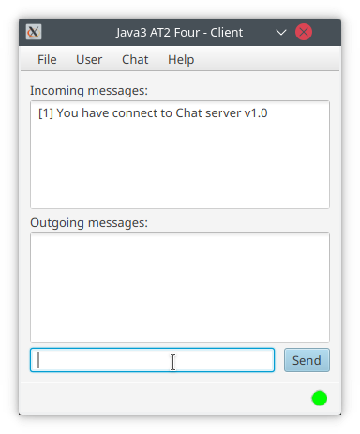

Figure 12 – Have a Chat - A

Figure – Have a Chat - B

Figure – Have a Chat - C

Figure – Have a Chat - D

Figure – Have a Chat - E

Figure - Close session - A

Figure - Close session - B

Figure - Logout - A

Figure - Logout - B

Figure - Show Help/About - A

Figure - Show Help/About – B

Figure - Help/Manual - A

Figure - Help/Manual - B

Figure - Login with wrong password - A

Figure - Login with wrong password - B

Figure - Show validation of new Username & Password - a

Figure - Show validation of new Username & Password - B

Figure - Show validation of new Username & Password - C

Figure - Show validation of new Username & Password - D

Figure - Show validation of new Username & Password - E

Figure - Show validation of new Username & Password - F

Figure - Show validation of new Username & Password - G

Figure - Show validation of new Username & Password - H

Figure - Show validation of new Username & Password - I

Figure - Show validation of new Username & Password - J

Figure - Logout

Figure - Show servers running with last sessions logs

Figure - Show both servers shutdown

Figure - Trying to Login – Connection refused

Figure - RMI Server (Login Server) restarted

Figure - Login now successful

Figure - Try to open Chat session - Connection refused

Figure - Socket Server (Chat Server) restarted

Figure - Chat session connected

Figure - Logout with Chat session open - A

Figure - Logout with Chat session open - B

Figure - Final look at server consoles with log entries

Figure - Close application

# References